What is Capability Maturity Model?
The Software Engineering Institute (SEI) Capability Maturity Model (CMM) specifies an increasing series of levels of a software development organization. The higher the level, the better the software development process, hence reaching each level is an expensive and time-consuming process.

Levels of CMM
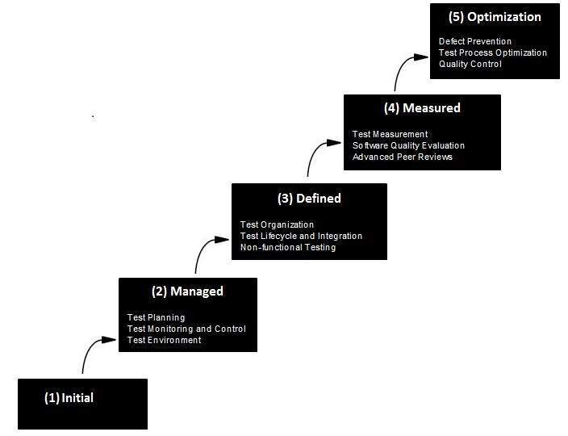
- Level One :Initial - The software process is characterized as inconsistent, and occasionally even chaotic. Defined processes and standard practices that exist are abandoned during a crisis. Success of the organization majorly depends on an individual effort, talent, and heroics. The heroes eventually move on to other organizations taking their wealth of knowledge or lessons learnt with them.
- Level Two: Repeatable - This level of Software Development Organization has a basic and consistent project management processes to track cost, schedule, and functionality. The process is in place to repeat the earlier successes on projects with similar applications. Program management is a key characteristic of a level two organization.
- Level Three: Defined - The software process for both management and engineering activities are documented, standardized, and integrated into a standard software process for the entire organization and all projects across the organization use an approved, tailored version of the organization's standard software process for developing,testing and maintaining the application.
- Level Four: Managed - Management can effectively control the software development effort using precise measurements. At this level, organization set a quantitative quality goal for both software process and software maintenance. At this maturity level, the performance of processes is controlled using statistical and other quantitative techniques, and is quantitatively predictable.
- Level Five: Optimizing - The Key characteristic of this level is focusing on continually improving process performance through both incremental and innovative technological improvements. At this level, changes to the process are to improve the process performance and at the same time maintaining statistical probability to achieve the established quantitative process-improvement objectives.

